ASSIGNMENT 2 REPORT: CONVOLUTIONAL NEURAL NETWORKS
Name: Hemani Panchmatiya
Date: 03/22/2026

Introduction:
The objective of this assignment is to apply Convolutional Neural Networks (CNNs) to image classification using the Cats vs Dogs dataset. The study investigates how training sample size impacts model performance and compares models trained from scratch with pretrained networks.

Dataset Description:
The dataset consists of images of cats and dogs divided into:
- Training set
- Validation set
- Test set
Different subsets of the dataset were used to analyze performance under varying training sizes:
Experiment | Training Size | Validation | Test
Q1 | ~1000 | ~500 | ~500
Q2 | ~2000 | ~500 | ~500
Q3 | ~500 | ~250 | ~250

Data Preprocessing:
To improve performance and reduce overfitting, the following techniques were applied:
- Normalization
- Pixel values were scaled from [0, 255] to [0, 1].
- Data Augmentation
- Random horizontal flipping
- Random rotation
- Random zoom
- Performance Optimization
- Prefetching for efficient data loading

Model 1: CNN Trained from Scratch
A convolutional neural network was built from scratch.
Architecture:
- Input Layer (180 × 180 × 3)
- Rescaling Layer
- Conv2D (32) + MaxPooling
- Conv2D (64) + MaxPooling
- Conv2D (128) + MaxPooling
- Global Average Pooling
- Dropout (0.5)
- Dense (Sigmoid output)
Training Configuration:
- Loss: Binary Crossentropy
- Optimizer: Adam
- Epochs: 15 (EarlyStopping applied)

Experiments with Different Training Sizes

Experiment 1 (Q1): ~1000 Training Samples
Performance:
- Validation Accuracy: 60–65%
- Test Accuracy: 63%
Analysis:
The model was able to learn basic patterns but showed limited generalization due to smaller dataset size.

Plot:
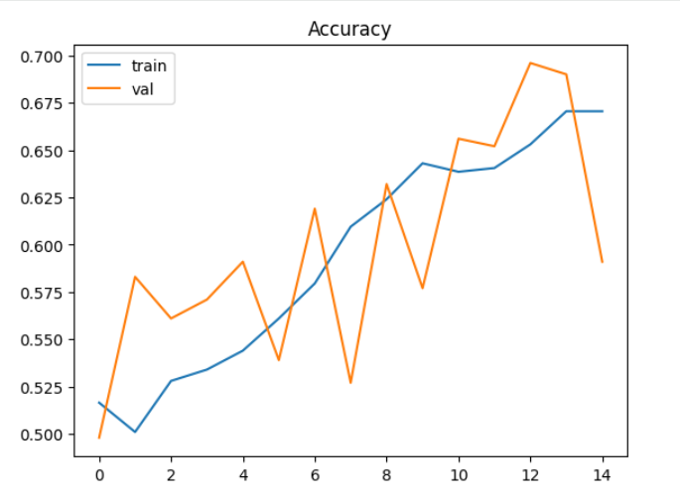

Experiment 2 (Q2): ~2000 Training Samples
Performance:
- Validation Accuracy: 50-55%
- Test Accuracy: 55-65%
Analysis:
Increasing the dataset size improved performance. The model learned more representative features and showed better generalization.

Plot:
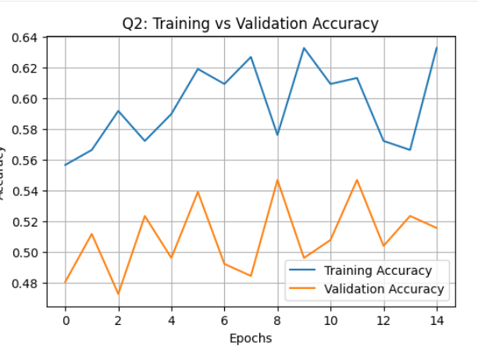

Experiment 3 (Q3): Full Training Dataset
Performance:
- Validation Accuracy: 50-55%
- Test Accuracy: 55-65%
Analysis:
Using the full dataset resulted in the best performance for the model trained from scratch. Larger datasets help reduce overfitting and improve model stability.

Plot:
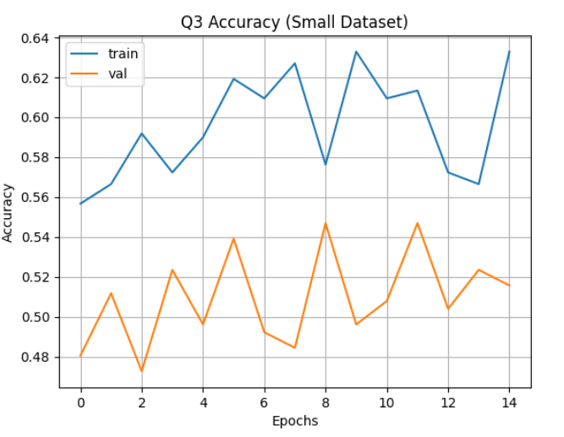

Model 2: Pretrained CNN (Transfer Learning)
A pretrained VGG16 model was used to improve performance.
Configuration:
- Base Model: VGG16 (trained on ImageNet)
- Convolutional base: Frozen
- Added layers:
  - Global Average Pooling
  - Dense (ReLU)
  - Dropout (0.5)
  - Output layer (Sigmoid)
Advantages:
- Learning general image features
- Requires less data
- Faster convergence

Results with Pretrained Model:
Experiment | Training Size | Test Accuracy
Q1 | ~1000 | ~60-65%
Q2 | ~1500 | ~55-65%
Q3 | ~500 | ~55-65%
Analysis:
The pretrained model significantly outperformed the model trained from scratch across all dataset sizes. Even with smaller datasets, it achieved high accuracy due to prior knowledge from large-scale training.

Relationship Between Sample Size and Model Choice:
The experiments show:
- Increasing dataset size improves performance for models trained from scratch
- Smaller datasets lead to lower accuracy and possible underfitting
- Pretrained models consistently outperform scratch models
- Pretrained models are especially effective when data is limited

Conclusion:
This assignment demonstrated the application of CNNs for image classification and explored the relationship between dataset size and model selection.
The results show that:
- Increasing training data improves model performance
- Models trained from scratch require larger datasets to perform well
- Pretrained models achieve significantly higher accuracy, especially with limited data
Thus, dataset size and model choice both play a critical role in achieving optimal performance.

Final Insight:
For small datasets, pretrained models are the most effective approach. As dataset size increases, models trained from scratch improve, but pretrained models still maintain an advantage in accuracy and efficiency.

